EX.NO:1
Create Database & Table
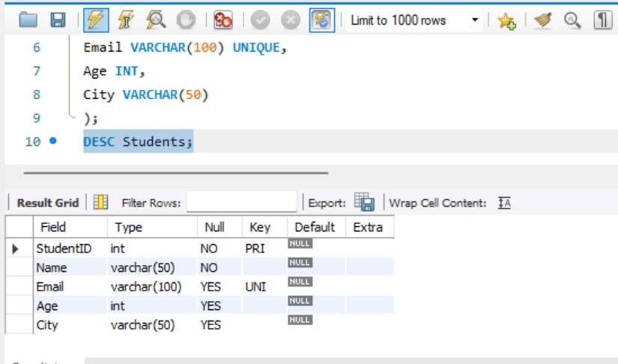

This SQL code creates a database named College_db and a table named Students with columns for StudentID, Name, Email, Age, and City. It uses constraints like PRIMARY KEY, NOT NULL, and UNIQUE to maintain data accuracy.
The USE command selects the database, and DESC Students displays the table structure, including column names, data types, and constraints.

